# INTRODUCTION

* 1. Overview

EVENT MANAGEMENT APPLICATION USING SALESFORCE

Develop an App for the Property Management where Buyer can order his Requirements and get the Appropriate Details of the Property. According to his interest just provide him with some discounts upto what extent he can get the discount.

* 1. Purpose

Also Track Whether he is Interested in taking the loan available for so just calculate how much loan Amount user can get it. Provide the Security for two different profiles like for marketing and sales team.

1. **Problem Definition & Design Thinking**
   1. Empathy Map

Paste the empathy map screenshot

* 1. Ideation & Brainstorming Map

Paste the Ideation & brainstorming map screenshot

# RESULT

* 1. Data Model:

|  |  |
| --- | --- |
| **Object name** | **Fields in the Object** |
| obj1-Buy | |  |  | | --- | --- | | Field label | Data type | | State | Pick list | | Discount | percentage | |
| obj2-Rent | |  |  | | --- | --- | | Field label | Data type | | State | Pick list | | BHK Type | Pick list | |

# Activity & Screenshot

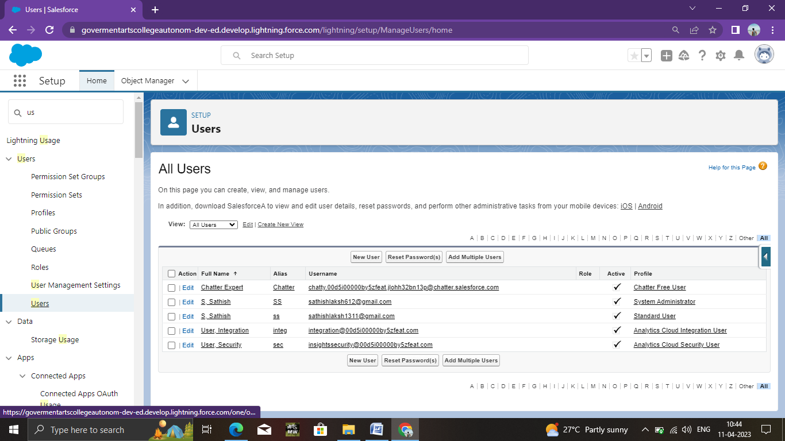Attach the screenshots of your project activity along with the description.

Develop an App for the Property Management where Buyer can order his Requirements and get the Appropriate Details of the Property

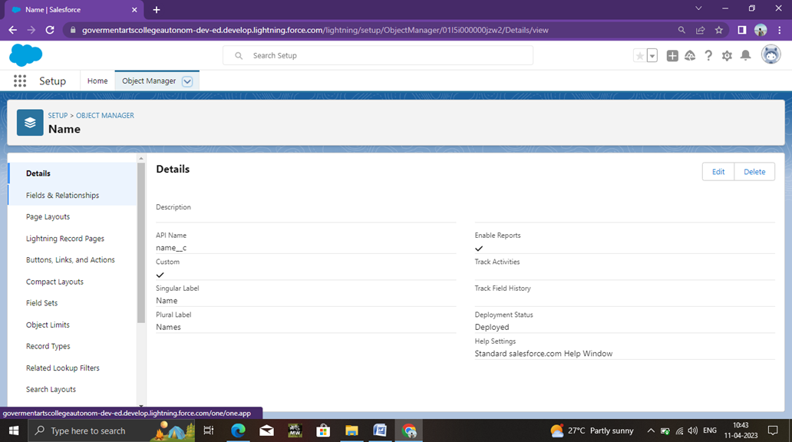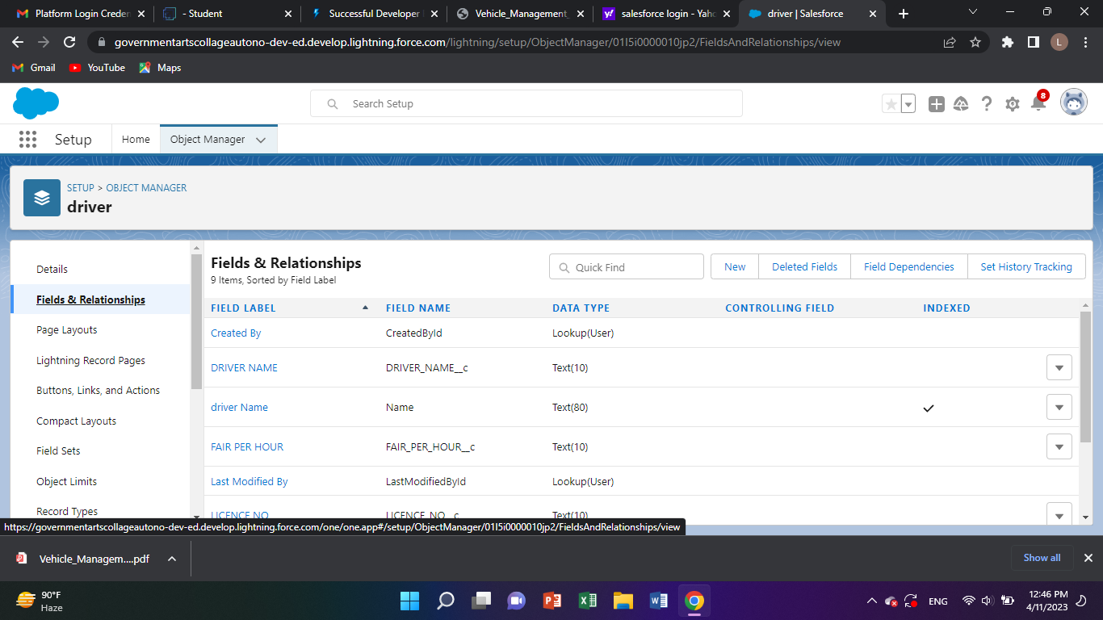

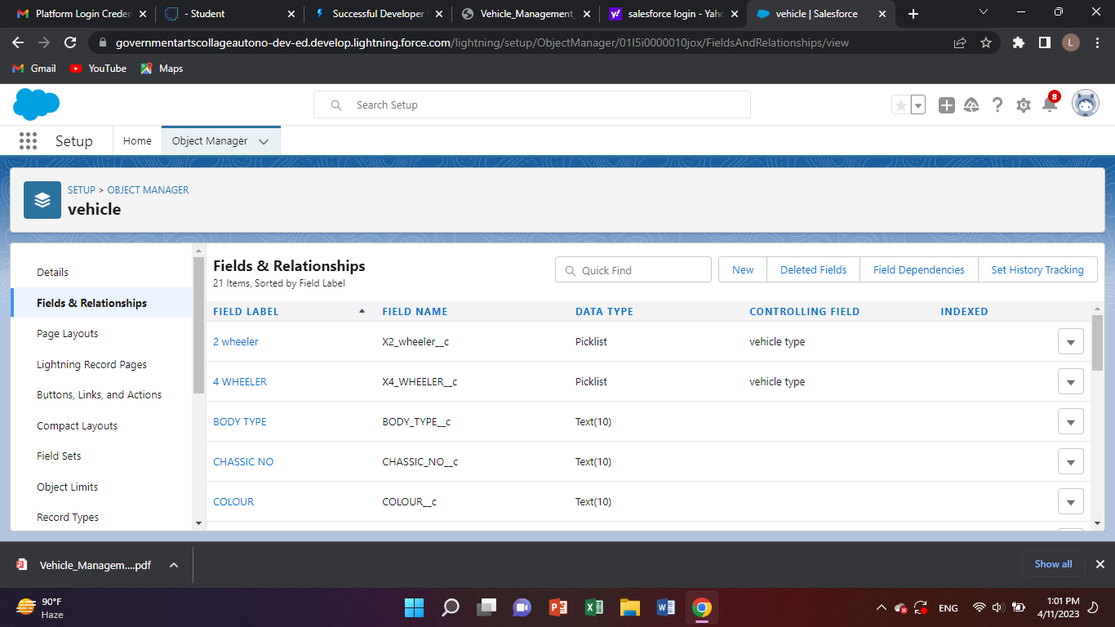

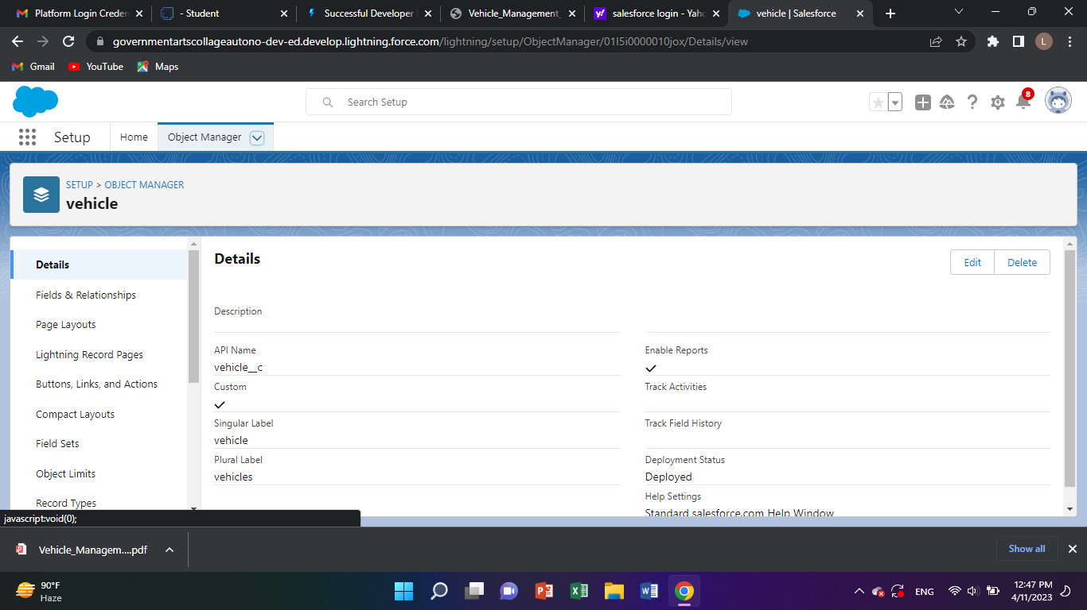

# Trailhead Profile Public URL

**Team Lead –**

**NIKILA K**

**https://trailblazer.me/id/nikila17**

**Team Member 1 –**

**RENUGA DEVI S**

**https://trailblazer.me/id/res25**

# Team Member 2-

# SURUTHIKA M

# https://trailblazer.me/id/suruthi36

# Team Member 3 –

# SIVAPRIYA S

# https://trailblazer.me/id/privj

1. **ADVANTAGES & DISADVANTAGE**

ADVANTAGES

* Improved visibility in property portfolios and cataloging of property units, and leasesextension.
* Enterprise-level system security and data protection.

DISADVANTAGES

Overly simple user interface that is quickly outgrown by experienced users.

# APPLICATIONS

Provides a management model. The application takes into consideration the best management practices, which allows it to consolidate the way in which its team of collaborators works and carry out a more complete and detailed management.

# CONCLUSION

Develop an App for the Property Management where Buyer can order his Requirements and get the Appropriate Details of the Property.

# FUTURE SCOPE

# As the demand for any salesforce job role is high,the scope

# For career growth and salary is sky high.